Template for ICSOBA 2025 – Abstracts and Papers

Xxxx¹, Yyyy² and Zzzz³
1. Position of Xxxx
2. Position Yyyyy
Affiliation of Xxxx and Yyyy (if from the same company), City, Country
3. Position and affiliation of Zzzz, City, Country
Corresponding author: abc@xyz.com
https://doi.org/10.71659/icsoba2025-xxYYY

Abstract

Text here……….

Keywords: Keyword1, Keyword 2, Keyword 3, Keyword 4, Keyword 5.

Section Title

Text here……….

Sub-Section Title

Text here……….

Sub-Section Title

Text here……….

    - Sub-Section Level 2 Title

Text here……….

Section Title

Text here……….

Table Example

Table 1. Thermal conductivity and electrical resistivity of different ramming pastes [3].
Type of paste | A | B | C | D | E
Thermal conductivity at 1 000 °C (W/m⸳K) | 11.9 | 13.1 | 13.9 | 16.2 | 13.9
Electrical resistivity at 1 000 °C  (µΩ⸳m) | 67 | 52 | 48 | 36 | 37

Figure Examples

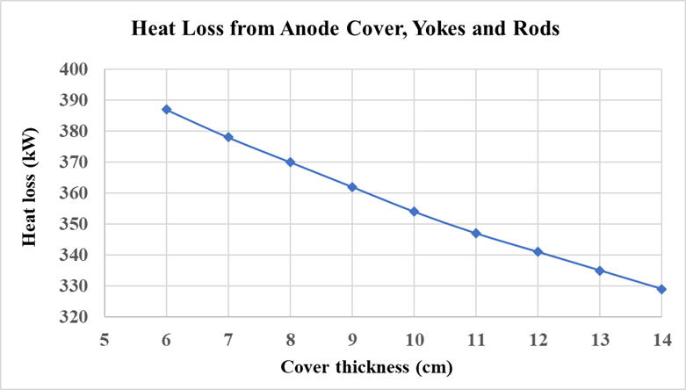
Figure 1. Heat loss from anode cover, yokes and rods [2].

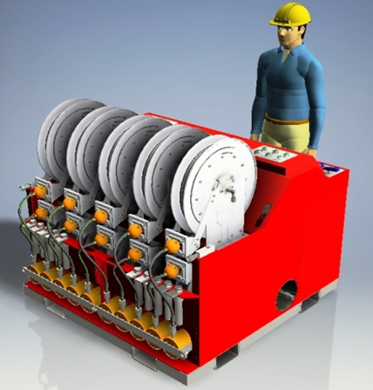 | 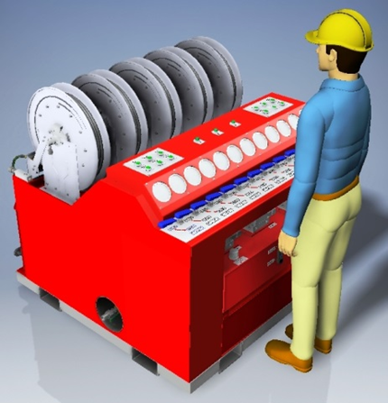
Figure 6. New hydraulic wedge puller. Left: back view, Right: front view.

Equation Example

Text here… Example – The Newton’s second law is governed by the following formula:

$F=ma$ (1)

Where
F Force, N
m Mass, kg
a Acceleration, m/s²

Conclusions

References

- Abdalla Al Zarouni et al., Energy and mass balance in DX+ cells during amperage increase, Proceedings of 31st International Conference of ICSOBA and 19th International Conference “Aluminium Siberia”, 4–6 September 2013, Krasnoyarsk, Russia, TRAVAUX 42, 494–499.
- Morten Isaksen et al., The complexity of PFC generation in alumina reduction cells, Proceedings of 42nd International ICSOBA Conference, Lyon, France, 27–31 October 2024, TRAVAUX 53, 1759–1766. https://doi.org/10.71659/icsoba2024-al059
- J.Y. Hwang, X. Huang and Z. Xu, Recovery of metals from aluminium dross and salt cake, Journal of Minerals & Materials Characterization & Engineering, Vol. 5, No. 1, (2006), 47–62.
- Bjarte Øye, Could the chloride process replace the Hall-Héroult process in aluminium production?, SINTEF Blog, https://blog.sintef.com/sintefenergy/energy-efficiency/could-the-chloride-process-replace-the-hall-heroult-process-in-aluminium-production/ (Accessed on 4 October 2019).
- Warren E. Haupin, Light Metal Production, US Patent 3,755,099, filed Sept. 8, 1971, granted August 28, 1973.

